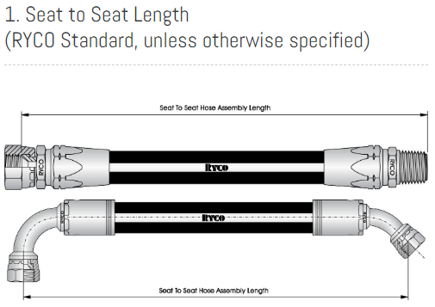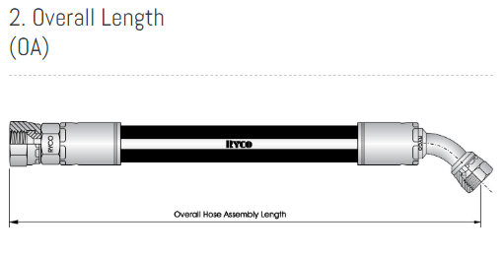
4. Fitting Orientation (ORI)
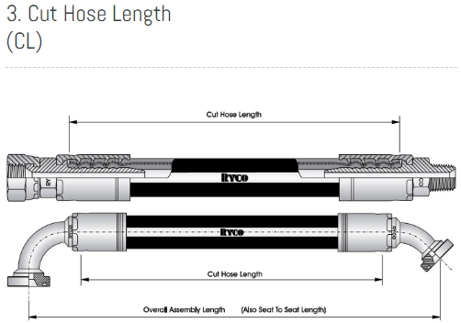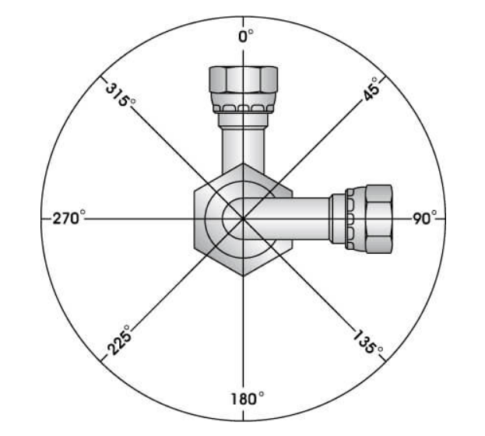
Work order #: | Customer: | Date:
System PSI: | Hose Size ID: | Hose Part Number:
Fitting #1: | Fitting #2: | Seat To Seat:
Overall Length: | Hose Cut Length: | Fitting #1 ORI:
Fitting #2 ORI: | Crimp Die#: | Crimp Setting:
Ferrule OD#1: | FerruleOD#2: | Hose Cleaned: Yes / No
Hose Sealed: Yes / No | Hose QTY: | Hose #__ OF __
System PSI: | Hose Size ID: | Hose Part Number:
Fitting #1: | Fitting #2: | Seat To Seat:
Overall Length: | Hose Cut Length: | Fitting #1 ORI:
Fitting #2 ORI: | Crimp Die#: | Crimp Setting:
Ferrule OD#1: | FerruleOD#2: | Hose Cleaned: Yes / No
Hose Sealed: Yes / No | Hose QTY: | Hose #__ OF __
System PSI: | Hose Size ID: | Hose Part Number:
Fitting #1: | Fitting #2: | Seat To Seat:
Overall Length: | Hose Cut Length: | Fitting #1 ORI:
Fitting #2 ORI: | Crimp Die#: | Crimp Setting:
Ferrule OD#1: | FerruleOD#2: | Hose Cleaned: Yes / No
Hose Sealed: Yes / No | Hose QTY: | Hose #__ OF __
System PSI: | Hose Size ID: | Hose Part Number:
Fitting #1: | Fitting #2: | Seat To Seat:
Overall Length: | Hose Cut Length: | Fitting #1 ORI:
Fitting #2 ORI: | Crimp Die#: | Crimp Setting:
Ferrule OD#1: | FerruleOD#2: | Hose Cleaned: Yes / No
Hose Sealed: Yes / No | Hose QTY: | Hose #__ OF __
System PSI: | Hose Size ID: | Hose Part Number:
Fitting #1: | Fitting #2: | Seat To Seat:
Overall Length: | Hose Cut Length: | Fitting #1 ORI:
Fitting #2 ORI: | Crimp Die#: | Crimp Setting:
Ferrule OD#1: | FerruleOD#2: | Hose Cleaned: Yes / No
Hose Sealed: Yes / No | Hose QTY: | Hose #__ OF __
System PSI: | Hose Size ID: | Hose Part Number:
Fitting #1: | Fitting #2: | Seat To Seat:
Overall Length: | Hose Cut Length: | Fitting #1 ORI:
Fitting #2 ORI: | Crimp Die#: | Crimp Setting:
Ferrule OD#1: | FerruleOD#2: | Hose Cleaned: Yes / No
Hose Sealed: Yes / No | Hose QTY: | Hose #__ OF __

